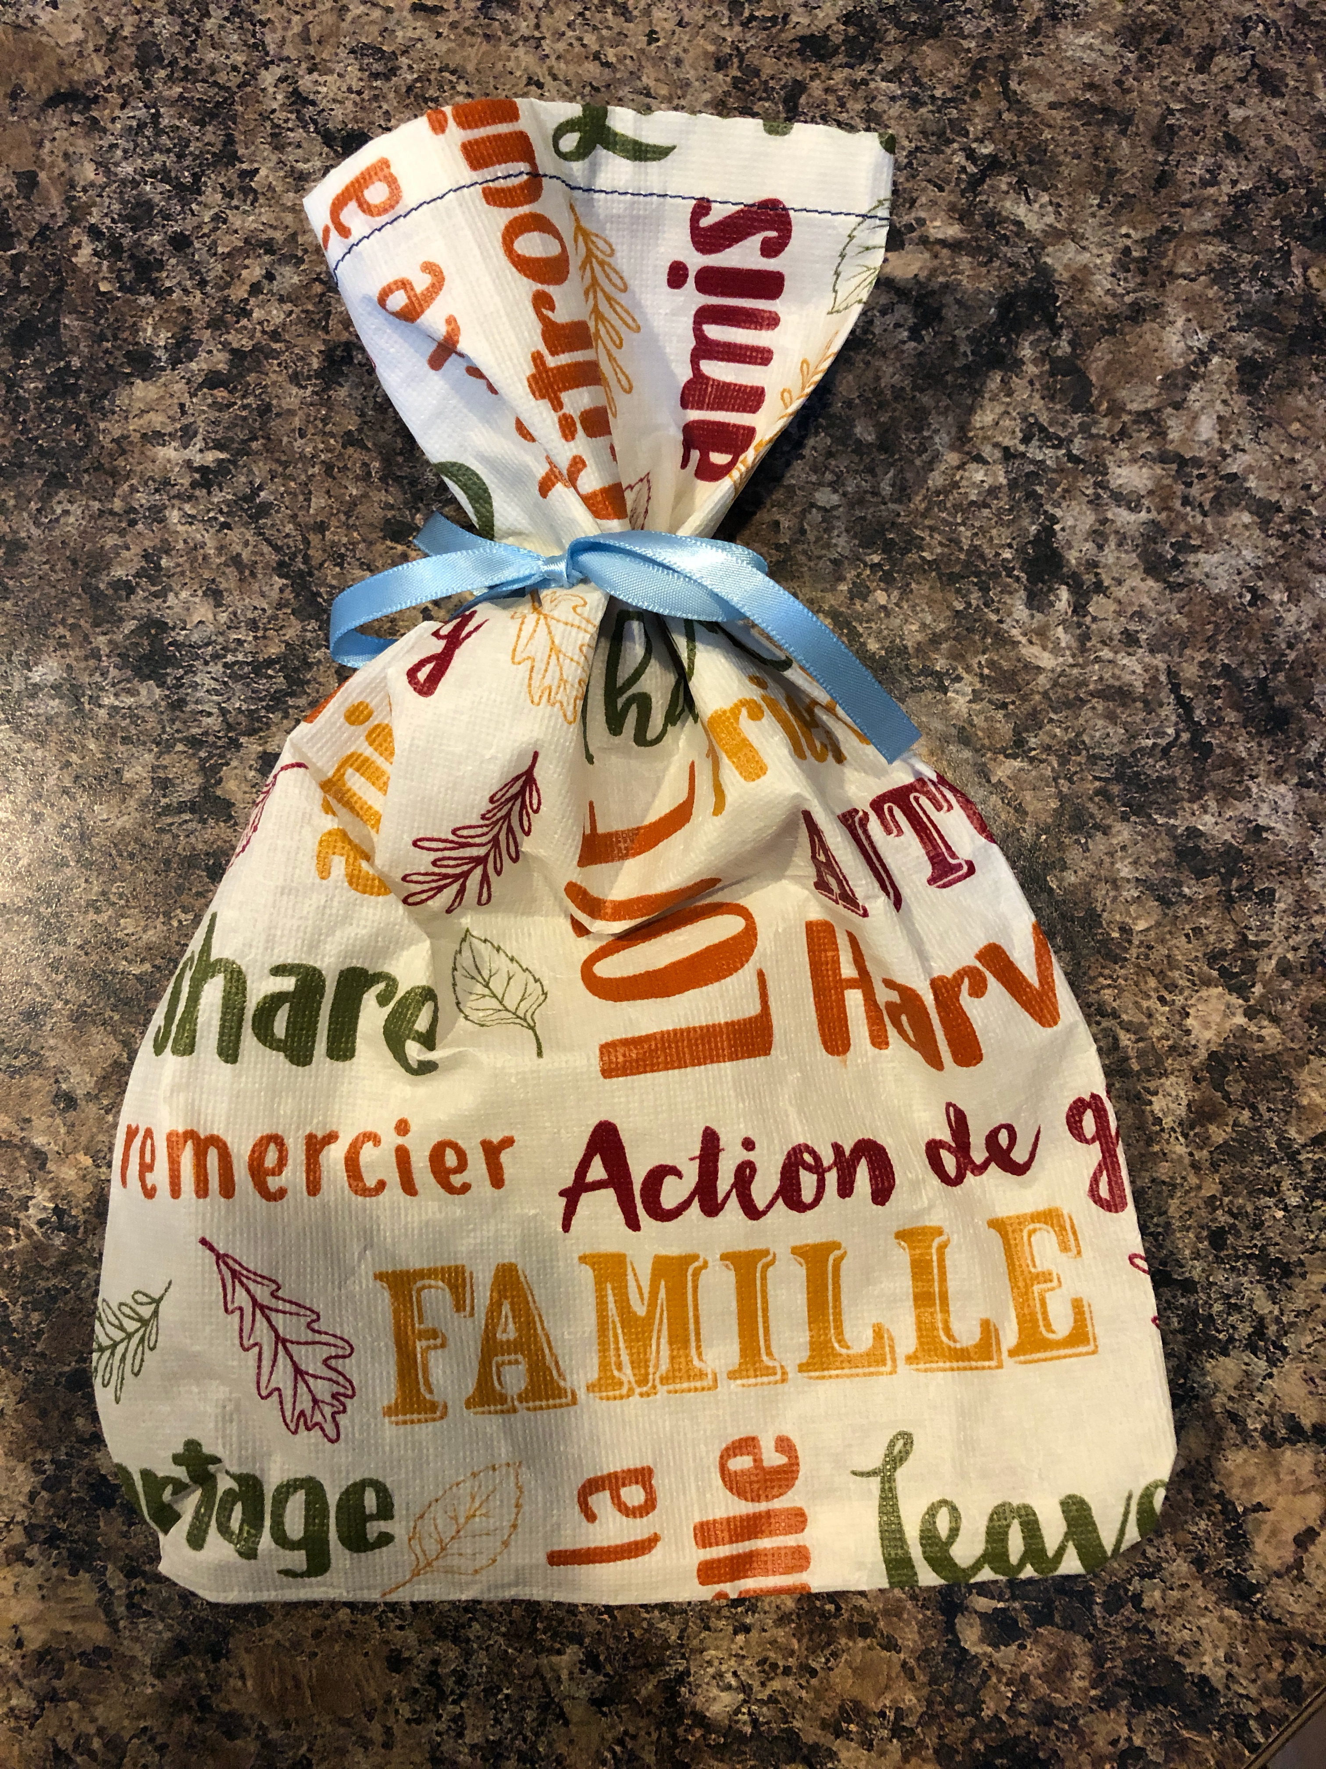
Hygiene Bags - these are used to transport the soiled pads home for washing

- Cut 12” squares using a fabric that is water resistant (blackout fabric, nylon ripstop, raincoat material, PUL, etc.).

- Take the square of fabric and turn 1/4” down and then 1/4” down again on one side to make the top hem of the bag. Zigzag the turned edge down (if you don’t have a zigzag option on your machine, you can straight stitch).

- Fold the fabric in half, right sides together, with the finished hem on top (one long side will be the fold so the bag will be sewn along one side and the bottom).

- Take one piece of ribbon (about 20” long) and fold it in half. Tuck the ribbon into the bag and place the folded edge of the ribbon 2” down from the top edge of the bag in line with the open side of the bag. This will make the external tie for the bag.

- Stitch down the open side, making sure to back stitch at the start and end to make the seam strong and also stitch back and forth over the ribbon twice so that it is well attached. As you sew around the bottom of the bag, you can make square or round corners.

- Turn the bag inside out to make sure the ribbon is well attached to the side. Please don’t tie up the bag, just leave it flat.

